

ROAD TRAFFIC REGULATION ACT 1984 - SECTION 14 (2) (a)
The Isle of Wight Council (Blackgang Road, Niton)
(Temporary Road Closure and Revocation of one-way Restriction) Notice No 1 2026

TEMPORARY ROAD CLOSURE - Blackgang Road Niton
NOTICE IS HEREBY GIVEN under Section 14 (2) (a) of the Road Traffic Regulation Act 1984, that Ringway Island Roads Ltd, acting on behalf of the Isle of Wight Council, because works are being or are proposed to be executed on or near the road, considers that the closure to the road as specified below should come into force without delay.

ROAD TO BE CLOSED: Blackgang Road from its junction with Star Inn Road, for a distance of 44 metres in a Westerly direction.
ONE WAY TO BE REVOKED: Blackgang Road from its junction with Star Inn Road for a distance of 93 metres.
DIVERSION ROUTE(S): The diversion will affect these streets: Star Inn Road, Church Street, Newport Road, Niton Road, Appleford Road, Chale Green, Chale Street, Church Place, Blythe Shute, Blackgang Road.
Diversion route(s) will be signed at the time of closure. Reasonable facilities will be provided to allow access to adjacent premises while the road is closed.

PERIOD OF CLOSURE: From 14:30 hours on 15th June 2026, for a maximum period of five days or until works are complete, whichever is sooner.
I attach a copy of a plan showing the location of the road to be closed and alternative route.

If you have any queries regarding the above please contact Island Roads on 01983 822440.
Copies of all traffic orders may be viewed on the public notices website https://one.network

Scott Headey Strategic Manager - Highways and Transportation
Isle of Wight Council
St Christopher House 42, Daish Way, Newport, Isle of Wight PO30 5XJ
15th June 2026

PLAN OF CLOSURE:
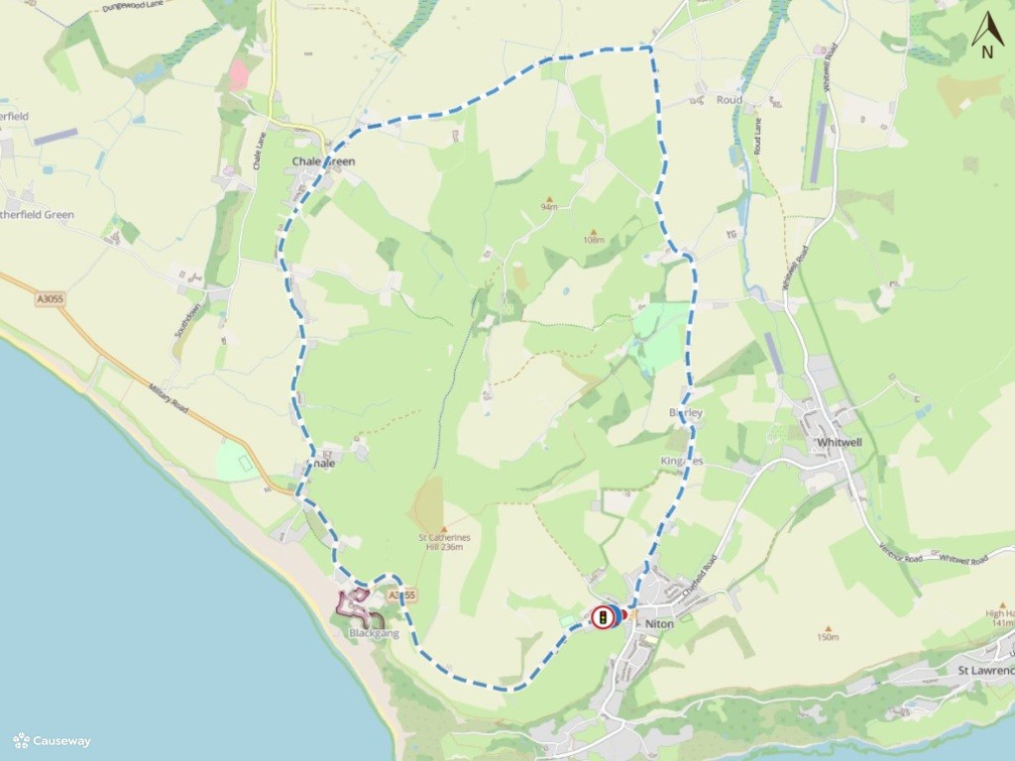
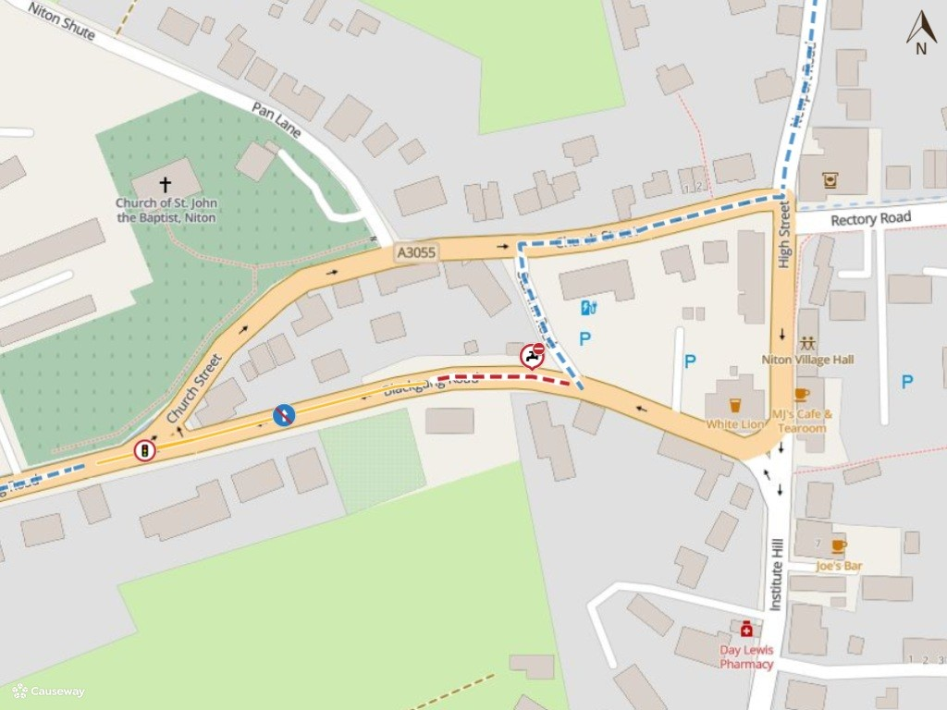

Imagery © 2026 MapTiler | Imagery © 2026 Hexagon | © MapTiler © OpenStreetMap contributors

